Creating React Application

1. Create a new folder, name it as React.
2. Open Visual Studio Code
3. From the menu bar File->open folder

Open the React folder.

After selecting folder it will appear like the following.

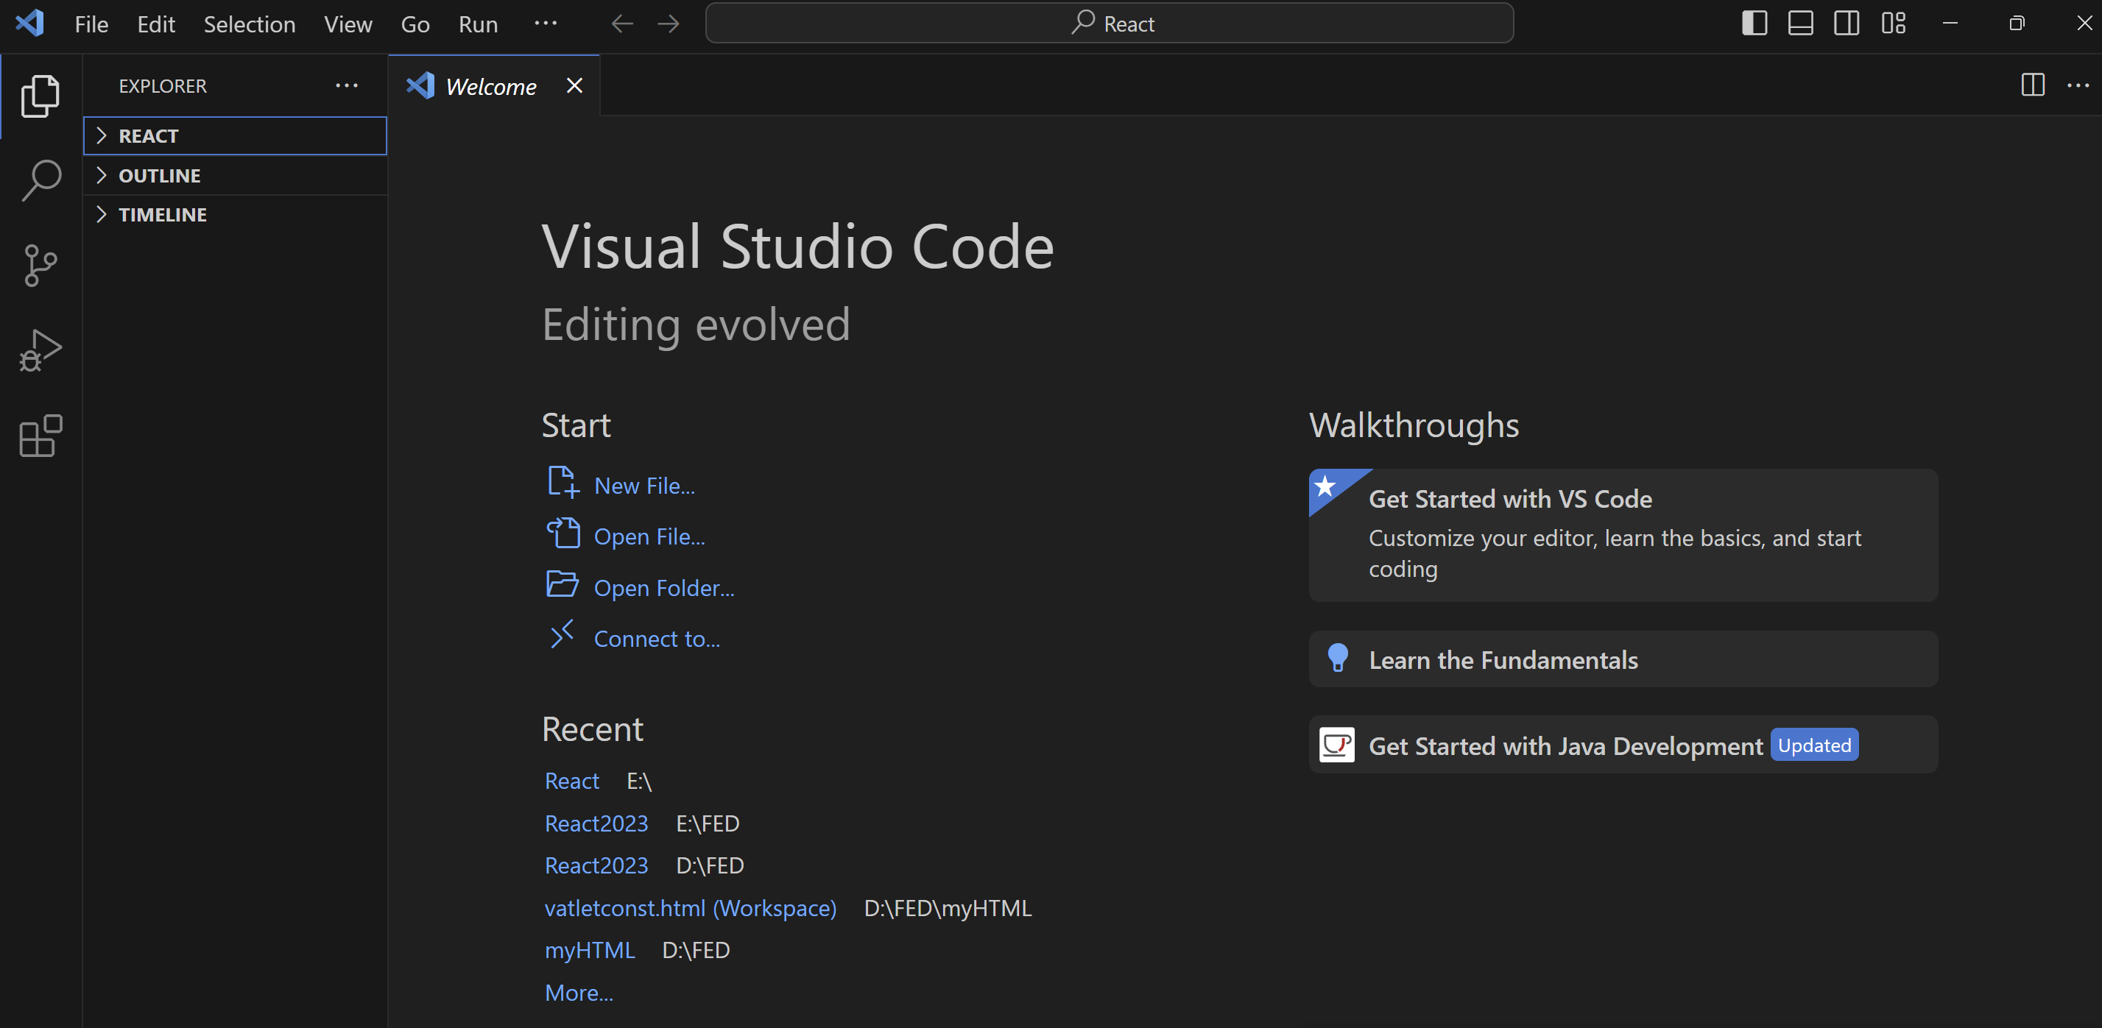

1. Click on new Terminal from the Terminal menu

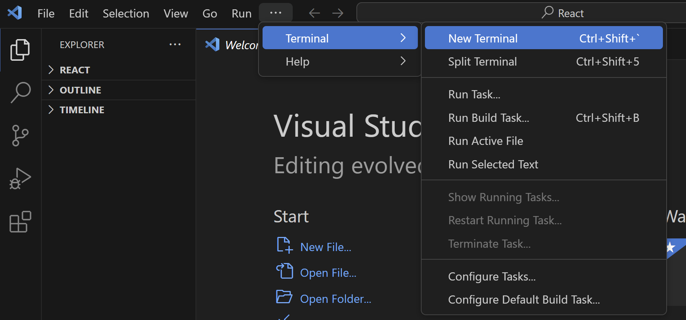

It will look like



If your current working directory is not selected by default change into current working directory like the above.

1. Now give the command **npx -v**

If it will not give the version, if you get the npx is not recognised as Internal or external command error then restart the Visual studio code then do the same.

If you get the version then create the app by using the following command

**npx create-react-app myapp**

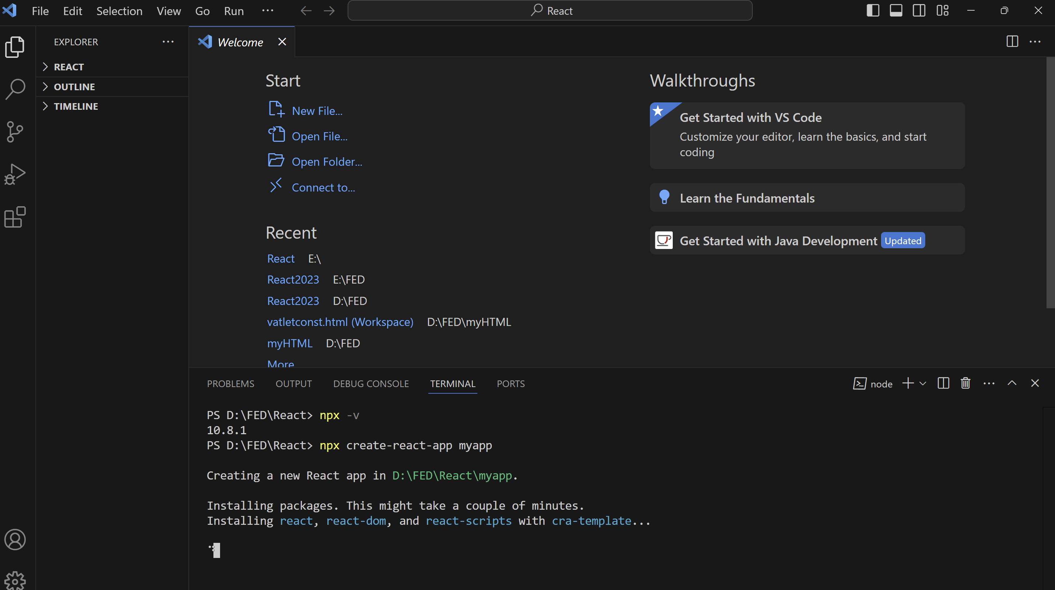

After the app is created you will get like the following

1. **Do the above that is**

D:/FED/React> cd myapp

D:FED/React/myapp> npm start

Npm start command will start running the app. After giving the command the app will rrun on the browser.Default app will be executed then you will get the following.

Then go to the visual studio code, go to the explorer window, expand **React folder**, expand **myapp. Expand src,** observe the files created

